ORTHERN EXPOSURE
Newsletter of the
New England Region
of the National Garden Clubs, Inc.
July 2015
Connecticut – Maine – Massachusetts - New Hampshire - Rhode Island - Vermont

DIRECTOR’S MESSAGE
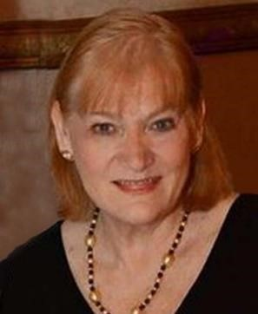
Theme: “Let’s Protect Tomorrow Today”

Regional Project: To work together to call on the resources of all of our committees to enhance our environment.

Website: www.ngcner.org

I would like to take this opportunity to tell you how honored I am to be serving as your New England Regional Director. I will do the very best that I can
to work with the whole region to combine and coordinate our resources to enhance the effectiveness of the New England Regional Garden Clubs.
Those of you who have agreed to work as Committee Chairs, thank you! Together we will make a difference to fulfill the goals and objectives of our organizations. The six state presidents and several committee chairs have offered to contribute articles to each quarterly edition of the Northern Exposure. The Northern Exposure provides vital and useful information that we encourage you to share with your entire membership.
We are so fortunate in New England to have states that have a common history and mindset.
Our twenty three thousand members are close in proximity allowing for cross border collaboration.
With this commitment to improving our environment, the 2015-2017 administration’s theme is “Let’s Protect Tomorrow Today.”
Protecting our earth is more critical today than ever before! We are all aware of our need to conserve, protect and preserve any and all aspects of our environment. Climate change, pollution and land abuse are wreaking havoc on our world. This is a global problem for which the New England Region is in a position to help remedy. As members of NGC and NER we are charged to educate anyone and everyone who will listen. We owe this to our organization, our future generations and our planet earth.
We in the New England Region are striving to work with our states, clubs, communities and youth to educate, collaborate and promote interest in being part of a needed change.
We will work together, call on the resources of all of our committees to enhance our environment, act as responsible stewards of the land and to take our NGC President Sandra Robinson’s call to “Leap into Action” to Protect Tomorrow Today!

Vera Bowen
New England Region Director 2015-2017

Table of Contents

New England Regional Annual Meeting – pages 2 and 3
NER Publicity Press Book Results for 2014 – page 4
NH Holds Flower Show Symposium – pages 4 and 5
New State Presidents
Maine – pages 6-8
Vermont – page 8
Rhode Island – pages 9 and 10
When you receive this newsletter, please feel free to forward it to anyone you believe
would be interested in reading it. It is the property of the New England Region of the
National Garden Club but we hope that you will free
ly share it with other garden club
members and the general public.

Nancy Atwell, NER Newsletter Editor

New Hampshire– pages 10 and 11
Massachusetts– pages 11 and 12
Connecticut – pages 12-14
Butterfly Information and Photos – pages 14 and 15
Roseland Cottage in Woodstock, Connecticut – pages 15-17
Are You a Safe Gardener? – pages 17 and 18
NER Calendar - pages 19 and 20

81st New England Regional Annual Meeting
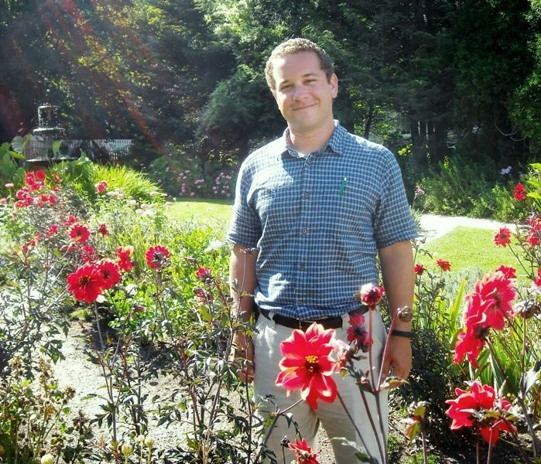
October 20-21 the New England Region of the
National Garden Clubs will be held at the Portsmouth
Harbor Events and Conference Center, Portsmouth, NH. Registration is 2-4 p.m. Oct. 20 in the hotel lobby. From 6-7 p.m. there will be a cocktail reception in honor of NGC President Sandra H. Robinson and NER Director Vera E. Bowen. Following dinner at 7
p.m. Erik Wochholz will present his program “History
of Period Flower Arranging: An Historical Journey
Through the Evolution of Floral Design in New
England” immediately following our dinner on Tuesday, October 20th. His presentation will venture from the colonial period to the modern era of Portsmouth

81st New England Regional Annual Meeting - continued

history, exploring period arrangements of all styles, from small posies to large-scale arrangements.
Erik, curator of Historic Landscapes at Strawbery Banke in Portsmouth, graduated from the
University of New Hampshire with a B.A. in Philosophy in 2001 and received a B.S. in
Environmental Horticulture in 2007. He joined the Strawbery Banke Historic Landscape Department in 2012. Concentrating his studies on environmental conservation and the history of agriculture, Erik has more than 16 years of experience in botany, floriculture, vegetable and fruit management, and agronomy.
NER Director Vera Bowen will preside at the Annual Business meeting from 9:15-10:30 a.m.
Tuesday.
Peter Randall will be our speaker Tuesday prior to our luncheon. The topic of his program will be “Celia Thaxter’s Theatre Garden,” a 30 minute film showcasing the photographs he acquired while conducting research for his book Out on the Shoals: Twenty Years of Photography on the Isles of Shoals. The film will be personally narrated by Mr. Randall, one of New Hampshire’s best known editorial photographers, a native of the New Hampshire seacoast and the twelfth generation of his family to live in the region. Randall graduated from the University of New Hampshire with a major in history and has been involved with publishing ever since. Originally an editor of a weekly newspaper, he went on to become editor of New Hampshire Profiles magazine, later starting his own publishing company.
Since 1974 Mr. Randall has authored 14 books, nine of which feature his photographs, ranging from collections of photographs and travel guides to local history. In 1979 he published his first book of New Hampshire color photographs, New Hampshire Four Seasons and two volumes about the Isles
of Shoals. His photographic work includes a collection of his panoramic photographs of New Hampshire (1996) and New Hampshire Then & Now, 80 sets of historical and contemporary photographs of the Granite State from 1840 to 2005 published in 2006. His most recent books include Ghana: An African Portrait Revisited; New Hampshire: A Living Landscape and Portsmouth Marine titles including: Gosport Remembered: the Last Village at the Isles of Shoals. Mr. Randall’s 1985 Portsmouth Marine Society publication There Are No Victors Here: A Local Perspective on the Treaty of Portsmouth has recently been reprinted. Most of Mr. Randall’s work has been devoted to New Hampshire, the Isles of Shoals, Maine and nearby areas, however he has also photographed in the American Southwest, Ghana, Japan, Togo, Senegal, Zimbabwe, Zambia, Guatemala and Spain and his editorial photographs have been utilized by the United Nations as well as regional and national magazine and book publications. You may register for the annual meeting by completing the form that has been distributed at meetings and is now on the NHFGC and NER websites or by using the tri-fold brochure that arrived attached to your e-mail along with this newsletter. However hotel reservations must be made directly with the hotel. Please contact the Hampton Inn & Suites Portsmouth Downtown (603) 430-3033. Located at 23 Portwa.lk Place (100 Deer Street) Portsmouth, New Hampshire 03801. Be sure to mention:
“NER” in order to receive your discounted double room (2 queen beds) rate of $149.00 + tax. NOTE: This room rate includes a complimentary hot breakfast buffet. Deadline for reserving rooms is September 30 for the NER rate.
Joyce Kimball, Annual Meeting Chairman

NER PUBLICITY PRESS BOOK RESULTS FOR 2014

SMALL CLUB: Sandown Garden Club, Sandown NH - 1st
i. 29 members & under Hameho Garden Club, Barrington RI - 2nd
North Haven Garden Club, North Haven CT - 3rd

MEDIUM CLUB: Andover Garden Club, Andover MA - 1st ii 30-59 member Sebasticook Garden Club, Newport ME - 2nd
Atkinson Garden Club, Atkinson, NH - 3rd
Sogkonate Garden Club, Little Compton RI - HM
LARGE CLUB: Kennebec Valley Garden Club, Augusta ME - 1st iii 60-99 members Opechee Garden Club, Lakes Region NH - 2nd
Evening Garden Club of West Roxbury MA - 3rd
Wallingford Garden Club, Wallingford CT - HM Rutland Garden Club, Rutland VT - HM

X-LARGE CLUB: Mountain Garden Club, Mt. Washington Valley, NH - 1st iv 100+ members Barrington Garden Club, Barrington RI - 2nd
Camden Garden Club, Camden ME - 3rd Wollaston Garden Club, Quincy MA - HM

NOTE: In all cases, the clubs receiving Honorable Mentions for their entries received scores of at least 90%.

Joyce Kimball
NER Publicity Pressbook Chairman

smbushnell@Comcast.net

New Hampshire Flower Show Symposium September 2-4

The first NH Flower Show Symposium will be held September 2-4, at the Radisson Hotel, 700 Elm St, Manchester, NH 03101, 603-625-1000. The lectures are open to all garden club members and to the public, upon payment of fees.
We have contracted fabulously talented instructors. There will be interesting and varied vendors, including Ken Swartz Bent & Twisted sculptures, dried plant material, containers, jewelry, floral design supplies and others.
Wednesday: The allied topics are It’s Magic, Photography by Arabella Dane and Here Comes the Judge by Penny Decker. Registration at 2:30-4 p.m., lectures start at 4:30 p.m. Includes Dinner.
Thursday: Is Design Day with Explosion of Color by Penny Decker. Registration 8 a.m.
Lectures start at 9 a.m. Includes Lunch.
Friday: Pam Braun will present Dazzling Dahlias and Up in the Air, Bromeliads. Registration 8 a.m. Lectures start at 9 a.m. Includes Lunch.
Special rates have been arranged with the Hotel, and will be honored the day before and day after the Symposium.

New Hampshire Flower Show Symposium September 2-4 – continued

Come for one day or the whole Symposium, there is always something to learn. Registration Brochures may be found on the NHFGC and NER websites. The following is a merely the registration form, the actual schedule is available on the sites.

- - - - - - - - - - - - - - - - - - - - - - - - - - - - - - - - - - - - - - - - - - - - - -

2015 NH SYMPOSIUM REGISTGRATION FORM
Name: ____________________________________________________________________ (PLEASE PRINT)
Address: ___________________________________________City:____________________
State: ______Zip: ________
Phone Home: __________________ Cell: _________________ Email: ________________________
Medical Dietary Needs: ________________
Current Date of “Good Standing” 12-31-_____
FULL TIME REGISTRATION
( ) $179.00 Full Course with Exam, All Instruction + 1 dinner, 2 lunches ( ) $179.00 Full Course Audit, as above.
( ) $174.00 Full Course, no credit, as above.
PART TIME REGISTRATION
( ) $70.00 Wednesday, 9-2-15 Allied Topics, includes dinner
( ) $78.00 Thursday, 9-3-15 Design, includes lunch
( ) $78.00 Friday, 9-4-15 Horticulture, includes lunch
MEAL CHOICES (circle one)
9-2 (Wed.) Chicken Madeira or Eggplant Parmesan
9-3 (Thurs.) Baked Ham & Cheese Sandwich or Grilled Veggie Wrap
9-4 (Fri.) Deli Market Buffet
$____________Total Enclosed

All checks payable to:
NHFGC marked for, 2015 Symposium Mail completed form and check to:
Registrar Eleanor Morrison, 255 Pemigewasett Shore Drive, Bristol, NH 03222 Email emorrison2@metrocast.net Phone 603-744-8271

DEADLINE AUGUST 1, 2015 - $10.00 late fee for registrations postmarked after August 1, 2015

Registrar Use Only
Date Received ________Check #________Number:______Exam Seat Number:___

Audiology, West Virginia University; Graduate

NNNN

Garden Club Federation of Maine
President 2015
-
2017

Name:
Suzanne (Marie) Bushnell

Address, tel., e
-
mail:
133
Gurnet Landing Rd.
,
Harpswell, ME 04079
;
207
-
729
-
5285 (
h
)
,
207
-
449
-
c
9369 (
)
,
smbushnell@c
omcast.net

Educational background:
B.S. Speech Pathology and
Certificate in Paralegal Studies, George Washington
University; did another year of Paralegal Studies at the
Landscape Architecture at the University of Rhode
New State Presidents

University of Louisville; also studied for a year in
Island.
Employment background: Speech Pathologist in public schools in West Virginia; moved to the DC area (northern Virginia) and (after getting Graduate Certificate as a Paralegal at George Washington University) worked in Federal Regulatory Affairs for the American Petroleum Institute; then went on to work as the Director of the Republican Research Committee’s Energy Task Force for the U.S. House of Representatives; left that job to be a Legislative Affairs Representative for a company called
SONAT in their Washington, DC office (the DC office was their lobbying group). SONAT stood for Southern Natural Resources (HQ was Birmingham, AL). Got married and traveled back and forth across the country with my Marine Officer hubby. So went back to being a paralegal for a law office in Kentucky (sole practicing attorney) and then for a large law firm in Kansas City. Retired to Maine with the thought of taking it easy!!
Family background (husband, children, dogs, whatever): One of 8 children (only 7 of us made it to adulthood but lost a sister in 1996). Parents are 91 and still going strong after retiring from WV to SC. Husband’s name is Bill (from Hollywood, CA) and he is a retired Marine Colonel. No kids and no indoor pets (we both have allergies to cats and dogs). We have a mixed menagerie of outside critters we consider our “pets” – squirrels of all shapes, sizes and colors as well as chipmunks (who come to the back door looking for handouts of peanuts), and birds who also come to the deck looking for food. Over the years we’ve had squirrels who’ve had no ears, three legs, no tails, you name it! My husband also trained a blue jay to catch peanuts in the air. We named the bird Toronto (after the Toronto Blue Jay’s baseball team). He/She would wait for my hubby to come outside, and then wait for the peanut to be thrown in the air before swooping down to catch it before it hit the ground. Not sure who trained who but it was something that entertained the neighbors and their grandchildren☺.

Garden Club Federation of Maine President 2015-2017- continued
Started in garden club when? How? Joined the Harpswell Garden Club in March 2004 as a result of a newspaper article that featured one of my neighbors talking about the club and gardening. Up to this point, I’d been doing volunteer work for the Maine Maritime Museum and needed a change. The extent of my gardening since we moved to Maine in 1994 (after my hubby retired from the Marine Corps) was to put in a small veggie garden and put in a few perennial gardens with no sense of direction as to what I was doing! The day I joined the club, the Chairman of the Navy Chapel Gardens remarked to anyone within the sound of her voice that she’d finally found someone who could take over the Chapel Gardens. She said this because I was one of the few people in the Club with a Department of Defense sticker on my windshield. You needed to have this to gain access to the Brunswick Naval Air Station after all military bases restricted access as a result of 9/11. Today I’m STILL the Chairman of the Navy Chapel Gardens (among other jobs) even though Brunswick Naval Air Station has been decommissioned. The Harpswell Garden Club still tends to the gardens while a group of retired military officers and others try to turn the Chapel and its gardens into a museum.
Theme/project Growing Together – Inspiring Change Project will be to encourage clubs to reach outside their current “comfort zone” by partnering with other individuals or organizations on a joint project. This could be a partnership with their local library, land trust, an entity within their own town government (beautifying the town dump!) or other governmental entities (the list is endless). The project can be one that furthers Sandy Robinson’s special projects (such as saving the monarch butterflies, frogs and other amphibians; mason bees; other pollinators, etc.) Or, the project can be something entirely different. The object is to inspire change in the way we’ve done things in the past and encourage growth of our clubs by partnering with others.
Favorite area of garden club: In my own club, it’s definitely the Wedding Committee. We do the wedding flowers for bridal parties, cutting the flowers from our own gardens and those of our generous neighbors. The money we raise is used to preserve the Union Church (built in 1841 and on the National Register of Historic Places). Our club has been preserving the church for 64 years! At the State level, it’s putting together programs to identify speakers for GCFM events. Allows me to let the creative juices flow.
Current favorite plant (tree, shrub, etc.) Why?: Hands down, it’s dahlias. Love having color in my garden late into the Fall. Also am a big fan of my Japanese maple (acer palmatum dissectum ‘Garnet’). It’s only about 4’ tall and took a major hit this winter when it lost a third of its weeping branches.
Favorite gardening book: Perennial All Stars by Jeff Cox (used to be on HGTV)
Your gardening hero?: Was Paul James of HGTV’s Gardening by the Yard until HGTV cancelled the program in 2009. Now I guess it would be the team of Elliot Coleman and Barbara Damrosch.
Is there anything else you’d like to add?: As you can probably tell, I’ve lived all across the country (WV, VA, CA, RI, KY, KS). So I’ve had the good fortune to see plants of all types and in many temperature extremes (lived in San Diego where the climate is perfect as well as the CA desert where the cactus and wild desert flowers pop out of the sand). Moving 7 times in 10 years with the military forces you to adjust quickly to any situation. I’m someone who actually thrives on doing things Garden Club Federation of Maine President 2015-2017- continued
differently (call it “thinking outside the box” for lack of a better description). While some like to say “why”, I would respond, “well why not!”

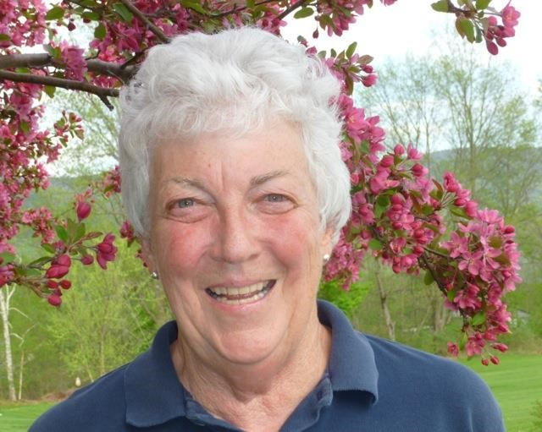
Federated Garden Clubs of Vermont
President 2015-2017
Name Susan Hinkel
Address, tel., e-mail 1064 N. Main St, Danby, VT 05739, 802-389-0033, rerob@mac.com
Educational background BA Connecticut College,
New London, CT, 1965; AARN De Anza College, Cupertino, CA, 1976
Employment background Mother (always!), RN in CA, NJ and Bennington, VT: 40 years.
Family background (husband, children, dogs, whatever) Divorced, widowed, remarried in 2013 after being a widow for 11 years. Met Don on-line, he moved in 6 weeks later lock, stock and barrel....... and chihuahua!! I had 2 labs and a ?? 90 pound bear! He has 3 children and I have 2, one outside San Francisco and one in Northern Ireland.
Started in garden club when? How? I moved to Manchester, VT in 1991, was doing flower arranging with a friend and asked her about joining the Garden Club of Manchester. I became CoPresident of our club from 1998-2000 and 2000-2002. Soon after that I became Secretary of FGCV. In 2007 I became the FGCV President for the first time!
Theme/project Jump In! Saving all our Pollinators!
Favorite area of garden club Too difficult to pick one area....... enjoy being with other gardeners and learning from them!
Current favorite plant (tree, shrub, etc.) Why? Love peonies....... wonderful smell, remind me of my Mother’s garden when I was little.
Favorite gardening book Too many to name.
Your gardening hero? Some of the older members of our club who know all the Latin names of plants!
Is there anything else you’d like to add? I’m looking forward to working with all the members in Vermont as well as rekindling friendships from my former term, in NER and all over the country.

Rhode Island Federation of Garden Clubs President 2015-2017

Name: Catherine Moore

Address, tel., e-mail:
11 Popon Road Watch Hill, RI 02891 401-348-8926 (cell) 401-374-5382 csimplymoore@cox.net

Educational background:
Bachelor’s in Business Administration
design courses at The Fashion Institute of Technology completed the Flower Show School courses

Employment background: Stylist/Colorist in the Garment District in NYC

Family background (husband, children, dogs, whatever): Husband is George C. Moore, Jr.( a budding floral designer), Chip 19, Faith 17, Shelby (schnoodle) and Fern (cat)

Started in garden club when? How? - I joined the Gardeners of Westerly around 1996 to meet people in my community.

Theme/project - “Rejunvenating the RIFGC”. My
president’s project is to plant two Breast Cancer Awareness Healing Gardens in the state.

Favorite area of garden club - Floral Design

Current favorite plant (tree, shrub, etc.) Why? - Peonies, because of their fullness, color and size.

Favorite gardening book - My favorite Floral Design book is anything by Marie-Francoise Duprez’.

Your gardening hero? - Debbie Myers (a member of my local garden club)

RIFGC President’s Report

The warm weather is finally here and the cold winter is a distant memory. I just came back from a trip and my much-anticipated peonies were beginning to bloom. . . some to the size of dessert plates.
It is an honor to serve my state in this capacity and so far have been able to attend a Blue Star
Memorial Dedication and have enjoyed the input of our members to making our Federation stronger. I also attended the NGC convention in Kentucky and came away with many informative project ideas that will reflect National’s goal of bee and butterfly preservation and also frogs. At my first RIFGC President’s Report – continued

board meeting I promoted the National Projects and gave away a Butterfly House and a Bee House along with information papers I gathered at the Convention. I also promoted “The Frightened Frog“ book and gave a local school librarian 5 books with the curriculum and encouraged clubs to do the same.

"The butterfly counts not months but moments, and has time enough."
Rabindranath Tagore

Respectfully,
Catherine Moore
RIFGC President

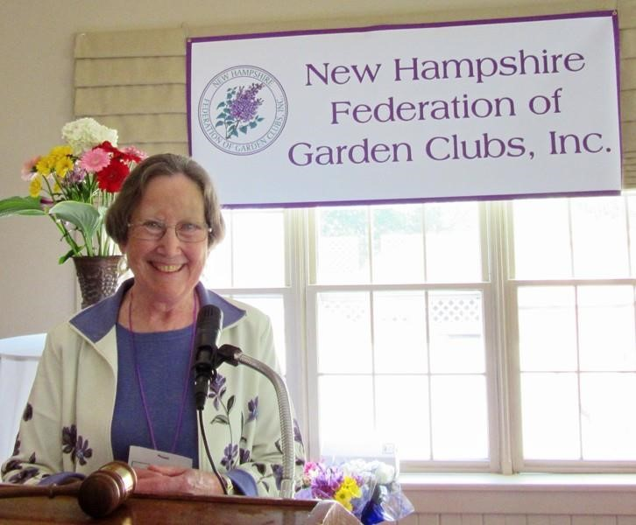
New Hampshire Federation of Garden Clubs

President 2015-2017

Name – Jane W. Goodwin

Address, telephone, e-mail – 13 Academy
Ave., Atkinson, NH 03811
603-362-5303,
penguinlongy@myfairpoint.net

Educational background – graduated Emma
Willard School, Troy, NY; 2 years Vassar
College, Poughkeepsie, NY; Graduated Dalcroze School of Music.

Employment background – Dalcroze teacher, private piano and flute lessons, several different elementary schools, community music schools, for fifty years. Currently junior and senior handbell choirs director, Lee Church Congregational Lee, NH.
Family background (husband, children, dogs, whatever) – Met my husband John in music school. We never had children of our own but we had pupils in and out of our home for almost fifty years and loved every minute of it!
Started in garden club when? How? - I always liked to be outside, mostly doing raking,, weeding, watching and listening. When we moved to New Hampshire, thirty years ago, I was invited to an Atkinson Garden Club meeting. They welcomed me so warmly that I went back on my own and the rest is history.

New Hampshire Federation of Garden Clubs President – continued

Theme/project - My theme for the next two years is "What if . . .??" I feel very strongly that we all need new ideas to help us keep growing in a good, positive way, whether we’re thinking individually or as groups.

Favorite area of garden club – Doing any kind of outdoor projects with club member! I also enjoy helping plan things, attending interesting programs and just “hanging out,” though there’s never much time for that
Current favorite plant (tree, shrub, etc.) - Whatever is blooming now! Or August, September, etc.

Things coming up in New Hampshire: the New Hampshire Federation of Garden Clubs is hosting a Flower Show Symposium Sept. 2-4 in Manchester, NH. Everyone is invited. There is more information elsewhere in this issue. After that comes the NER Annual Meeting in Portsmouth, NH. Hope to see lots of you there, too!

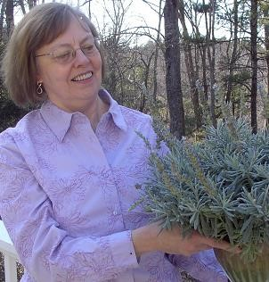
Jane Goodwin
President, NHFGC

Garden Club Federation of Massachusetts President 20152017

Name – Betty Sanders

Address, telephone, e-mail - 26 Pine Street, Medfield
MA 02052. (508-359-9453 betty02052@gmail.com) We just moved into a new house in April after 16 years on the other side of town. We downsized and now find ourselves without enough windows for all our houseplants. We are however thrilled to be creating a new garden from scratch allowing Neal and I to haunt
nurseries throughout New England for treasures for a virtually all native garden.

Educational background - I decided at 17 to become a chemist and graduated from Rensselaer Polytechnic Institute.

Employment background - Women scientists were not the rage back then so I spent a number of years with GE Plastics, a drug company and a chemical company as the token woman.

Family background (husband, children, dogs, whatever) - My husband had a more interesting job working in high tech, traveling frequently so I eventually quit working to travel the world with him. Ten years ago, Neal retired from the corporate world and began writing mystery novels. Nine have been published, several of which have garden club themes.

Garden Club Federation of Massachusetts President - continued

Started in garden club when? How? - I came late to the garden club world. In 2000, fresh back in New England from stints in Connecticut and Virginia, I was dragged to the Medfield Garden Club by an old friend. There I found a roomful of kindred spirits. Fifteen years later I have been that club's president, held eight jobs in the GCFM, attended all four schools and loved every minute of it.

Theme/project - My theme is "Growing Together" and my goal is that everyone sees that as growing personally (through education and friendships) growing our clubs and growing(or greening) our world.

Favorite area of garden club - I have no favorite area of garden club or of gardening. Vegetable gardening, native trees and shrubs, orchids, perennials and just about everything else . . . except invasive plants and poison ivy are favorites. The friends I've made, the lectures and classes that have made me a better gardener, the challenge of a floral design, the joy of being able to share that with others are the reasons I wish everyone could be a 'garden clubber.'

Favorite gardening book - Doug Tallamay is my current favorite author. "Bringing Nature Home" and "The Living Landscape" (with Rick Darke) are guides for thoughtful gardening in the 21st century.

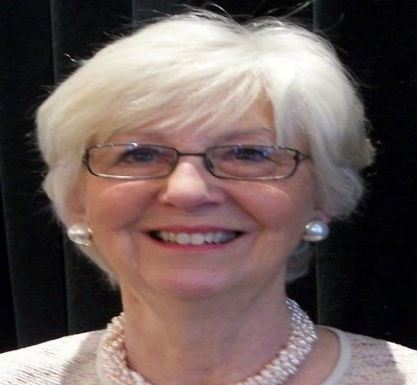
Your gardening hero? - My garden hero is the person who plants something for the first time and finds the magic, and gets hooked for life.

Federated Garden Clubs of Connecticut President 2015-2017

Name: Jane Waugh
Address: 210 Ocean Dr. E, Stamford CT, 06902-8134 (part time in Naples, FL – very little this year!)

tel.: 203-353-8956, cell 203-536-9539

e-mail: waugh@optonline.net

Educational background: Graduate of Barnard College of Columbia University as an Art History major
Employment background: Worked for American Banks in computer systems including in Japan for a few years. Continued work in online services such as banking, stock trading, airline reservations and ordering of groceries and flowers. Retired after working with internet products and services for a number of years.

Family background (husband, children, dogs, whatever): Originally from Pittsburgh, married for 40 years to Jim, now retired from IBM, no children.

Federated Garden Clubs of Connecticut President - continued

Started in garden club when? How?: Joined the Shippan Point Garden Club in Stamford, CT in 1988. A garden club neighbor heard that I had studied Ikebana in Tokyo and said, “You must join our garden club.” Still a member of that same club as well as the Gulf Coast Garden Club in Florida, the latter of which I get to attend very little.

Theme: GROWING TOGETHER:
TINY ACORNS TO MIGHTY OAKS

It has two distinct parts.
The first and most obvious part is related to planting oak trees, the White Oak being, not only our Connecticut State, but also our National Tree.
The second part of GROWING TOGETHER is a bit of a metaphor: Tiny acorns, the kernels, represent the beginnings of good ideas, which, with nurturing, can grow into mighty oaks. . . that is, into significant accomplishments.
GROWING TOGETHER defines a commitment on the part of The Federation to work more
closely with clubs, to develop ideas together and to share them, to the benefit of all. This includes a plan for several idea exchange symposiums among regional clubs with The Federation’s assistance and participation.

Project: Native Oak Tree Project

The Federation is helping to fund a native oak tree planting for all CT Garden Clubs. Here are the details:
What: Plant a CT native oak in a public location (park, school, street, etc.).

When: Now through April 1, 2017.
Why: It’s our state and national tree and the best tree for supporting local wildlife.
How:
- Find a public location with lots of space for future growth.
- Obtain permission to plant there.
- Determine the best native oak variety for that location.
- Locate a native tree to plant; we can help.
- Establish a maintenance plan – who will mulch and water regularly the first 2 years.
- Buy the tree (save the receipt) and plant.

Federated Garden Clubs of Connecticut President - continued

Payment:
- The Federation will reimburse your club up to $200 for the tree (does not include planting).
- Submit a copy of the invoice with the following: club name, tree location, native oak tree variety, date planted, brief description of planned maintenance, and the contact person and address to which the Federation check should be mailed.
- No special format is required.
- A photo of the tree and/or dedication would be most welcome.

Project Chair Contact information: BARBARA DEYSSON email: barbara.deysson@raveis.com

Favorite area of garden club: Can’t really choose one. Love the comradery of like-minded women and men.
Current favorite plant (tree, shrub, etc.) Why?: Has to be the oak at the moment. I grow quite a bit of dahlias kept in their own pots in the basement over the winter. Favorite gardening book: Many on trees, some pretty, some informative.
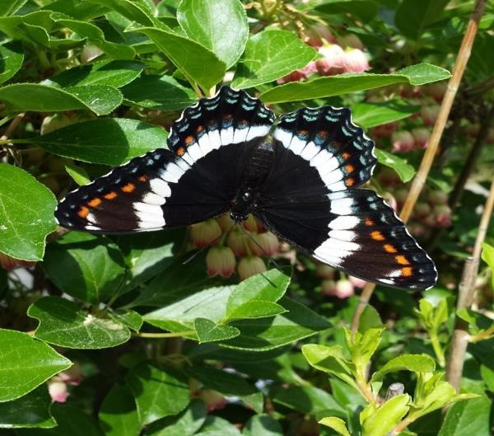
Your gardening hero?: Maybe would have to be my Dad who had my brother and me digging trees out of the woods to grow handsomely in our yard. Is there anything else you’d like to add?: Enjoy nature by kayaking on Long Island Sound and in the Everglades.

WHITE ADMIRAL BUTTERFLY

The White Admiral Butterfly (Limenitis arthemis) is a beautiful New England Butterfly. It is closely related to
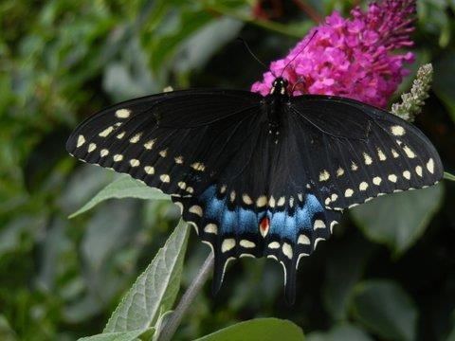
the Red Spotted Purple Butterfly, once thought to be a separate species, although almost identical except for the broad white stripes on its wings. This striking butterfly lays its eggs on the leaves of many trees and shrubs. Birches, Poplars and Aspens are some of its favorite host plants.
While out in my garden the other day, I noticed this gorgeous butterfly visiting the flowers on my Enkianthus shrub, although windy, I managed to take several photos as she sipped nectar from the tiny, bell-like flowers, oblivious of my presence. What a wonderful treat it is to observe nature in my own backyard! The delicate, iridescent purple and white stripes are perfectly created into a gift for human eyes. Take time in your gardens to get a glimpse of nature’s flying jewels!

BLACK SWALLOWTAIL BUTTERFLY

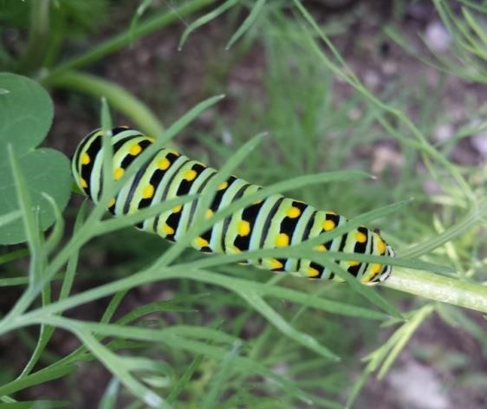
The Black Swallowtail Butterfly (Papilio polyxenes) is a magnificent large swallowtail butterfly. The female is black with bluish underwings and the male with yellow spots. Black Swallowtails love to lay their eggs on plants that are members of the carrot family. Parsley, Dill and Queen Anne’s Lace. I have a small vegetable garden, including herbs, such as basil, dill, parsley and chives. While weeding, I noticed a Black Swallowtail Butterfly attempting to lay eggs on my parsley and dill plants. My grandson watched in awe as the tiny yellow eggs were laid. The caterpillars grew, shed their skins and grew larger each day. Caterpillars shed their skin 7 times before forming a chrysalis. Please make sure that you don’t harm these caterpillars on your plants, as they will become one of the loveliest butterflies to grace our gardens!
I plan to share my butterfly, bird, bee and wildlife experiences with you in each edition of the Northern Exposure. Every season has its small miracles to be discovered and shared with all of my New England Garden Club friends.

Bee Happy and have Butterfly days,
Michelle Mensinger
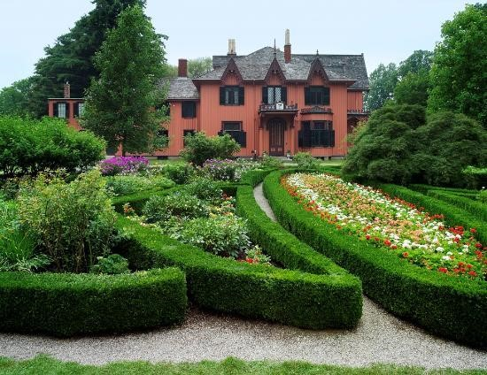
NER Bird, Butterfly and Wildlife Chairman

Roseland Cottage in
Woodstock, Connecticut

Contact information: 556 Route 169
Woodstock, Conn.
06281
Telephone: 860-928-
4074
Known to locals as “the Pink House,” this
Gothic Revival summer cottage, painted a
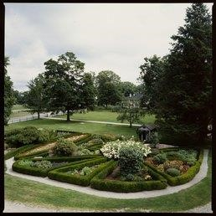
vibrant pink and set amidst a carefully planned landscape, is well-worth a drive to Connecticut’s Quiet Corner. Located near the historic Woodstock Common, the property is owned and operated as a museum by Historic New England; numerous programs are offered throughout the year, from concerts, lectures and fine arts and crafts festivals to an antique car show.
The interior of Roseland Cottage is equally colorful, and features elaborate wall coverings, heavily patterned carpets, and stained glass, much of which survives unchanged from the Victorian era. Built as a
Roseland Cottage in Woodstock, Connecticut – continued

summer home, Roseland Cottage also includes a picturesque landscape with original boxwood-edged parterre gardens planted in the 1850s, an icehouse, aviary, carriage barn, and the nation’s oldest surviving indoor bowling alley. It is described as one of the
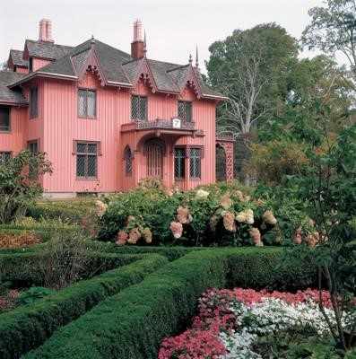
best-preserved and best-documented Gothic summer houses in the nation, with virtually intact interior decorations.
Roseland’s parterre gardens contain twenty-one flowerbeds with more than 4,000 annuals bordered in boxwood, in their original 1850 pattern, and now forming part of Connecticut's Historic Gardens. The entire complex of house, furnishings, outbuildings, and landscape reflects the principles of Andrew Jackson Downing, a leading nineteenth-century tastemaker.

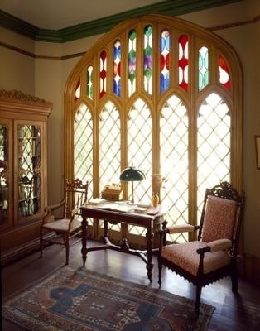
Built in 1846, Roseland Cottage was the summer home of Henry and Lucy Bowen and their young family. Prominently situated across from the town common, Roseland Cottage epitomizes Gothic Revival architecture, with its steep gables, decorative bargeboards, and ornamented chimney pots. Among Roseland’s many beautifully furnished rooms, the Conservatory was in the original plans for the house, but as the family grew and the use of the spaces changed, it was used as a library. See Conservatory photo below. Beyond the original 1846 stained glass window lies an impressive view of the Woodstock Common and the Woodstock Academy beyond. Henry C. Bowen was an active supporter of Woodstock even though he lived mostly in New York. He maintained the Common for several decades, even beautifying it with trees and decorative fencing. He also purchased, designed and maintained Roseland Park, a recreation area open to the people of Woodstock.
Henry Bowen was a Woodstock native who returned to his hometown after establishing a successful business in New York City. While Lucy Bowen enjoyed summers away from the city, her husband used Roseland Cottage as a place to entertain friends and political connections. Beginning in 1870, the largest Fourth of July celebrations in the United States were held at Roseland Cottage. Four United States Presidents visited Bowen's summer home as his guests and speakers for these celebration: Ulysses S. Grant, Benjamin Harrison, Rutherford B. Hayes, and William McKinley.

ALSO in the AREA:

Buttonwood Farm
473 Shetucket Turnpike
Griswold, CT 06351
860-376-4081

Less than an hour from Woodstock, in Griswold, CT, is Buttonwood Farm, a dairy farm renowned for its ice cream! But also on the property is an enormous field of sunflowers, to which photographers come every summer from miles away. Originally intended to simply beautify their property, the sunflowers were used to feed the cattle. It wasn’t long before a better use was made of
them, and Buttonwood’s owners established the “Sunflowers for Wishes" fundraiser which benefits
the Make-A-Wish Foundation of Connecticut. This organization is dedicated to making wishes come to fruition for children with life-threatening conditions. The original plantings were expanded to 10 acres in 2004, and this year 14 acres of sunflowers have been planted. Bouquets are created and given to anyone in exchange for a $5 donation to Make-AWish, on a first-come, first-served basis, with 100% of the proceeds donated to this organization. This year’s event will take place July 18-26, from 10:00 a.m. to dusk.
With two incredible properties, combined with the opportunity to benefit a worthy organization, a July drive to eastern Connecticut makes for a perfect outing!

Sandi Tinyk
NER Historic & Public Gardens Chairman

Are You a Safe Gardener?
Whether gardening is a pleasure or a chore, most of us have a garden that needs to be maintained. Pay attention to the following handy tips in order to help minimize the risk of injury and take the strain out of gardening.

The "Little and Often" Principle
Many tasks around the garden involve prolonged activities of a repetitive nature that may lead to aches and pains. To avoid strain, use the "little and often" principle or try switching from one task to another that uses a different group of muscles. For example: alternate digging with a job that involves stretching.

Avoid prolonged periods of:
• Gripping or repetitive jarring

Are You a Safe Gardener? - continued
- Bending or digging (Try some warm-up exercises to prepare your muscles for the hard work)
- Kneeling or sitting back on your heels (even with a kneeling mat).

Manual Handling and Back Care
many gardening injuries occur carrying heavy and frequently used equipment in and out of storage places. Make sure storage areas are easily accessible and avoid things like steps and tight corners.

Try to avoid working in a reaching position, (e.g.: do not hold hedge trimmers or shears too far in front of you).

When bending, digging and lifting keep your back straight and bend your knees.

Always try out tools for lightness and balance before buying them.

Reduce the effort of hoeing and pruning by making sure the blades on your hoe and pruning shears are sharp.

Handles of tools such as spades, shears, rake and hoes should preferably be long. Ladies size forks and spades are lighter and easier to manage.

10 Top Tips
- Take a break every 15 to 20 minutes or between every change of task.
- Mow grass while it is short.
- Hoe weeds when they are young and easy to deal with.
- Use a spade with a small blade to avoid the temptation of digging large spadefuls.
- Use raised flower beds to reduce bending when tending them.
- Place hoses strategically around the garden rather than carrying buckets and watering cans.
- Build your greenhouse workbenches to the correct height to avoid bending (2 inches below your elbow height).
- Choose pruning shears with a cut and hold (ratchet) action.
- Don’t overload your wheelbarrow.
- Go to a good garden center and investigate specially designed tools to reduce the strain on your back.
Pay attention to any discomfort, don’t work through pain. Seek medical attention if pain persists.

NER Calendar

Deadline for the next October issue of Northern Exposure in September 20– please e-mail articles or questions to editor Nancy Atwell at atwelln@aol.com

International, National and Regional Events

October 20-21 - New England Region Annual Meeting, Portsmouth Harbor Events Conference Center, Portsmouth, NH. See article in this issue.

Environmental Studies Schools

October 6-8 - Environmental Studies School, Course I at Kellogg Environmental Center, Derby, CT.

Flower Show Schools and Symposiums
September 2-4 – Flower Show Symposium held by New Hampshire at the Radisson Hotel, 700 Elm St, Manchester, NH. See information about symposium earlier in Northern Exposure (p.).

Gardening Study School
October 13-15 - Gardening Study School, Course II at CT Agricriculture Experiment Station, New Haven, CT.

Garden Tours
July 16 - Camden (Maine) Garden Tour (www.CamdenGardenClub.com)

July 19 - Bar Harbor Garden Tour (www.barharborgardenclub.com)

July 24 - Boothbay Region Garden Tour, for information call 207-633-5052 or 207-633-7405)

July 5, 12, 19 - Old York Garden Club Sundays in the Garden (www.oldyorkgardenclub.org)

Landscape Design Schools
November 19-20 NGC Landscape Design School, Course 1, St. Mary's Church, 43 Foreside Rd. Falmouth, ME. For more info: Harriet Robinson (harrietlewisrobinson@gmail.com).

State Garden Club Meetings
July 15 - Federated Garden Clubs of Connecticut Board Meeting, 10:00 a.m., TBD.

NER Calendar –continued

August 10 - GCFM Board Meeting, Viles House, Augusta (9:00 - Noon) with brown bag lunch to follow. Workshop for Club Presidents and District Directors (bag Lunch at noon, workshop 1:00 to 3:30 p.m.). For more information: Suzanne Bushnell (smbushnell@comcast.net).

October 5 – Federated Garden Clubs of Vermont Fall Board Meeting, Details TBA

October 5 - GCFM Board Meeting, Viles House, Augusta (9:30 a.m. - Noon).

October 27 – GCFM Fall Conference, Augusta Civic Center, Augusta (8:30 a.m. Registration; 9:15 a.m. Program). Theme: Taking Care of Your Selfie (www.mainegardenclubs.org)

